Sandwich maker :
After using the inputs from the dialogue flow this class diagram was generated.
As you can see in the snapshot the outline of the diagram is generated from the inputs and then the diagram is generated.
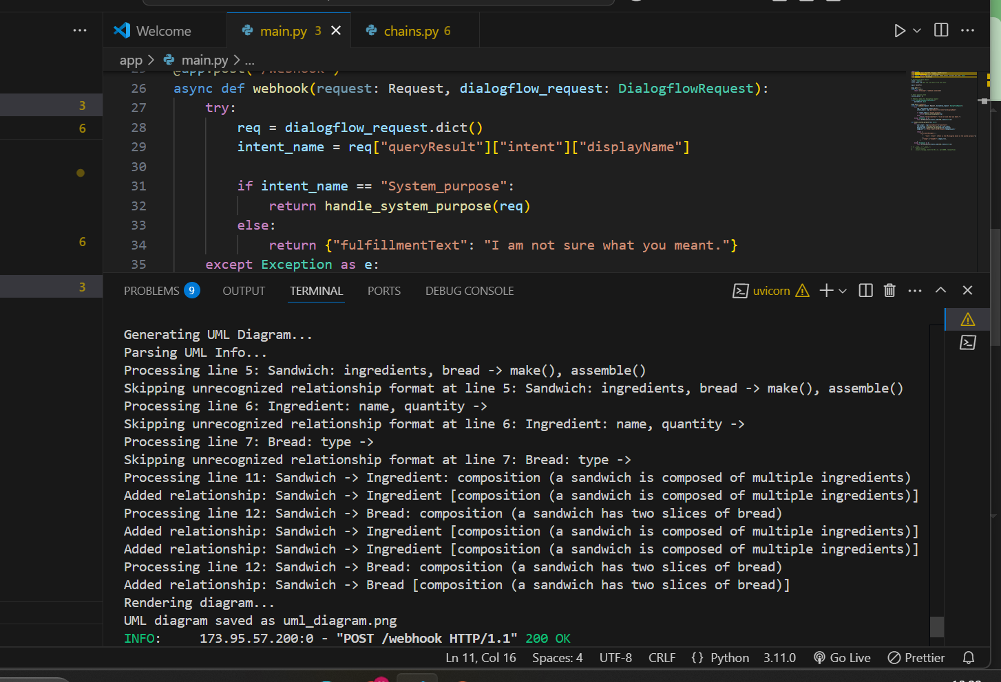
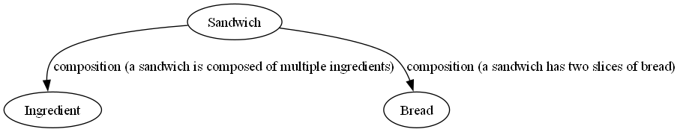
This is generated after the system purpose is used as a prompt for the generation of the UML Diagram.

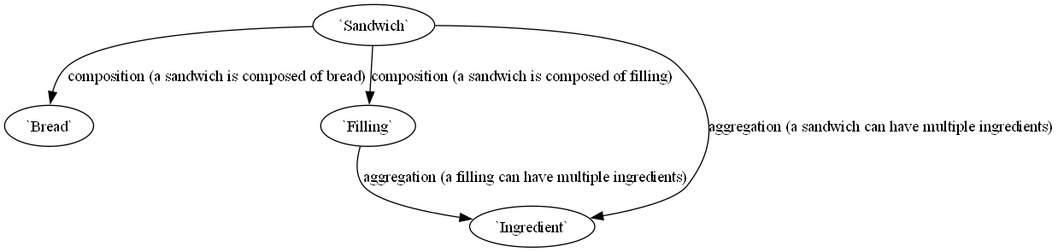

Food ordering system
